Effective Teaching in Integrative Studies Courses
A Workshop by PSU’s Schreyer Institute for Teaching Excellence
October 25, 2017

EXHIBITS:
- Taxonomy of significant learning
- Interdisciplinary habits of mind
- What’s your discipline?
- Special student challenges and some remedies
- Integrative learning rubric

EXHIBIT A: Taxonomy of Significant Learning (Dee Fink, 2013)

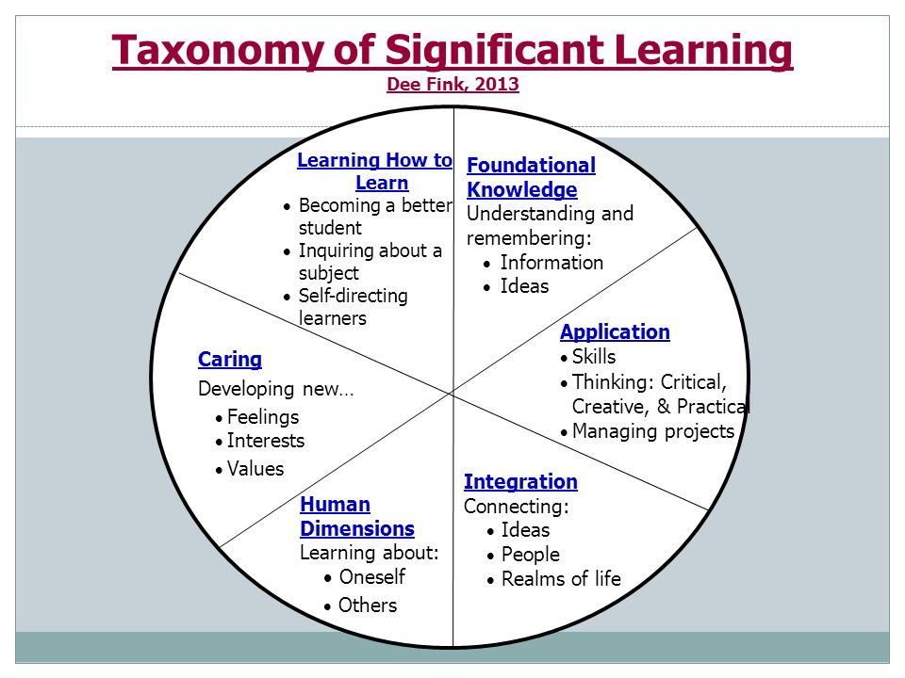

EXHIBIT B: Interdisciplinary Habits of Mind
This list provides instructional strategies that foster four key habits of mind.
Pedagogies Promoting Interdisciplinary Habits of Mind
- Drawing Insights:
  - Teaming diverse student backgrounds
  - Topics that necessitate interdisciplinary approaches (guest lectures, hot topics)
  - Bringing in faculty from different disciplines to explain how they approach a problem
  - Using real world examples
  - Using role playing (to help students detach from their own perspectives in non-threatening ways and imagine other ways of thinking about an issue, event, or position)
- Evaluating Insights:
  - Recognizing whether an insight is relevant
  - Having a good rubric and sharing it with students
  - Devil’s advocate assignment
  - Peer evaluation
  - Clicker-based responses
- Modifying Insights:
  - Role playing
  - Academic controversy (debate, class discussion)
  - Concept maps
  - Instructor models comparing and contrasting different insights with each other
  - Case studies that present unintended consequences, e.g. historical or current events can relate to students’ lives more efficiently
- Integrating Insights:
  - E-portfolios that connect elements with narrative
  - Multiple drafts with feedback, including face-to-face meetings
  - Creativity exercising
  - Case studies that introduce and revise assumptions, arguments and finally propose a different or extended argument
  - Teamwork/collaborative points

From: W.H. Newell & D.B. Luckie. (2013). Pedagogy for Interdisciplinary Habits of the Mind

EXHIBIT C: What’s Your Discipline?
Questions to Define Your Discipline:
- What are the goals of your discipline or field?
  - What does it try to understand?
  - What actions does it enable or guide?
- How does someone in your field actually spend their time?
  - E.g.: Wet lab, on a mountain, interviewing community leaders, reading primary sources, taking and analyzing photographs, dissecting plants, etc.
- What are the tools, equipment, materials, artifacts, or people you work with or study?
- Is there collaboration in your discipline?
- What benefits does your discipline bring to society?
- How is research in your discipline funded?
- What are your discipline’s blind spots?
  - E.g.: biases, provisions, limitations, etc.
- Identify two common stereotypes about your discipline. How is your discipline depicted in popular culture?
- Describe the historical development of your discipline.
- Would non-specialists recognize any of your discipline’s leaders and experts?
- In what research question are you currently most interested? What might this question mean to non-specialists?
- What moral or ethical questions does your discipline raise and/or respond to?
- Where is beauty and elegance in your discipline?

EXHIBIT D: Special Student Challenges and some Remedies
- Where do your students usually get stuck in your courses (i.e., what concepts, resources, or practices confuse them)?
  - Similarly, where did you get stuck as you were learning about the other discipline?
- Focus on the process of learning and students’ development as sophisticated and responsible thinkers and actors.
- Metacognition – reflecting on students’ own learning
  - Provide detailed rubrics prior to assignments. Include examples.
  - Ask them to reflect on their study skills (“What is the difference between studying and learning?” “How did you prepare for the quiz?”)
  - Provide frequent feedback
  - Focus on the processes (“Why did you select that option?” “How did you come up with that?” “What is the next step for you?” “What else would you need to know about X?”)
  - Ask students to reflect on and annotate their work
- Recognizing and accepting their own bias
  - Help them to depersonalize or dis-identify their opinions in order to examine them
  - Contextualize perspectives and values. (Example: Ask, “Given X’s experience, does their opinion on Y make sense?”)
- Tolerating ambiguity or divergence
  - Knowledge is constructed with certain goals and limits. (“From this perspective…” or “With the tools of this discipline…”)
- Unfamiliar classroom practices (group work, problem solving, class discussion, etc.)
  - Be clear about the goal, and ask students later about their experience with that activity
- Unfamiliar writing assignments, formats, and goals
  - (see EXHIBIT A)
- Unfamiliar resources, such as textbooks and primary sources, and the reading and analysis practices appropriate to each
  - Provide explicit guidance and goals, e.g., walk them through how to read critically, summarize/paraphrase, critique, etc. for the particular type of resource.
- The social or political dimensions of Integrative Learning topics and questions
- Cognitive and moral development (Knowledge “positions” according to William Perry and other developmental psychologists):
  - Dualism: There are right and wrong answers
  - Multiplicity: There are conflicting answers; students must trust their inner voices
  - Relativism: There are disciplinary reasoning methods
  - Commitment: Integrates knowledge learned from others with personal reflection
EXHIBIT E: Integrative Learning Rubric
