Effective Teaching in Integrative Studies Courses
ADDENDUMS

EXHIBITS:
F. A Cognitive Toolkit for interdisciplinary studies
G. Instructional strategies for cognition, motivation, & critical thinking
H. Disciplinary perspectives on: Human Cloning and Crime
I. Differences in academic writing between disciplines
K. Worksheet: Interdisciplinary Research Questions

EXHIBIT F: Interdisciplinary Studies’ Cognitive Toolkit
Interdisciplinary Studies: The “Cognitive Toolkit” (p. 91-108)
By: Repko, Szostak, Buchberger (2017)
The authors have put together a “cognitive toolkit” that describes the intellectual tools that students need to acquire in order to become integrative learners. The following four domains describe these necessary tools.
- Intellectual Capacities:
  - Perspective Taking: Viewing a problem from alternative viewpoints
  - Critical Thinking: The capacity to analyze, critique, and assess
  - Integration: Constructing a more comprehensive understanding of the problem
- Values:
  - Empathy: Identification with another’s thoughts, pains, situation
  - Ethical Consciousness: Self-knowledge that includes recognition of bias
  - Humility: Recognition of the limits of one’s training and expertise
  - Appreciation of Diversity: Being open to information from all relevant sources
  - Tolerance of Ambiguity: Openness to more than one interpretation
  - Civic Engagement: Use of political and nonpolitical means to affect quality of life in a community
- Traits:
  - Entrepreneurship: Taking risk to achieve a particular goal
  - Love of Learning: Excitement at the prospect of exploring new ideas
  - Self-Reflection: Self-conscious, careful thinking about one’s behavior and beliefs
  - Intellectual Courage: A capacity for independence of judgment
- Skills:
  - Communicative Competence: Regarding what is being communicated
  - Abstract Thinking: Understanding that a concept may have different meanings in different contexts
  - Creative Thinking: Combining previously unrelated ideas (“thinking outside the box”)
  - Metacognition: Awareness of your own learning and thinking processes
Ways to Apply Your Interdisciplinary Toolkit
To learn and to apply these tools, the authors suggest the following three types of student activities:
- Writing an Intellectual Autobiography (p. 104-106): The story of your academic or intellectual journey from your point of view, examining the assumptions and premises you have used in your life (see example on p. 340-342)
- Preparing a Portfolio (p. 106-107): That can help you document and explain interdisciplinary skills and how they are transferable to the workplace (see example on p. 346-348)
- Performing Service Learning (p. 108): Such a project provides you with an opportunity to apply your knowledge of interdisciplinarity in the real world (see example on p. 355-375)

EXHIBIT G: Instructional Strategies for Integrative Teaching
The following strategies can be used across disciplines, but may also be beneficial when applied to integrated learning tasks.

(1) Activating or Correcting Prior Knowledge:
Adapted from S. Ambrose, M. Bridges, M. DiPietro. (2010). How Learning Works.

- At the start of the semester, do a diagnostic assessment of what students already know (e.g. ask them to define 10-15 particularly important concepts in your course)
- Select typical misconceptions in your field and discuss them with your students
- Use everyday examples and analogies to help students connect their prior knowledge to the discipline
- Throughout the semester, look for patterns of error in your students work
- Help students recognize discipline-specific conventions (e.g. how writing in your discipline differs from other disciplines)
- Have students do a concept map of (parts of) your discipline (see below):
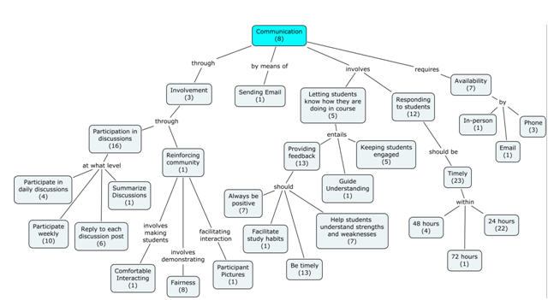

(2) Increasing Motivation:
Adapted from S. Ambrose, M. Bridges, M. DiPietro. (2010). How Learning Works.

Strategies to Establish Value:
- Connect the learning material with students’ interests
- Provide real-world tasks
- Show relevance to students’ current and future lives
Strategies to Build Positive Expectancies:
- Provide early success opportunities in class
- Clarify your expectations with rubrics (for examples, see: https://www.neiu.edu/about/office-institutional-research-and-assessment/assessment/resources-1)
Strategies to Help Students Connect their Values with their Expectancies:
- Provide flexibility in (some of) your assignments so that students can pursue their own interests
- Give students an opportunity to reflect about what truly motivates them

(3) Improving Students’ Metacognitive Skills:
Adapted from S. Ambrose, M. Bridges, M. DiPietro. (2010). How Learning Works.

- Assessing the Task At Hand:
  - Ask students to keep a process journal to explain their thought processes during a project
  - Tell students what you do NOT want (see also “rubric”)
  - Give students a performance rubric
- Evaluating Own Strengths and Weaknesses:
  - Give early, performance-based assessments (i.e., practice and timely feedback)
  - Provide opportunities for self-assessment (i.e. practice exams with answer key for self-assessment)
- Planning an Appropriate Approach:
  - Give students a set of interim deadlines for different deliverables, e.g.:
    - For a semester-long research paper: provide an annotated bibliography (week 4)
    - A draft of their thesis statement (week 6)
    - Evidence supporting their thesis (week 8)
    - Visual representation of their paper’s structure (week 10)
    - A complete draft that has been reviewed by 2 or more peers… and revised (by week 12)
- Applying Strategies and Monitoring Performance:
  - Require students to reflect on and annotate their own work
- Reflecting and Making Adjustments if Needed:
  - Ask students to analyze the effectiveness of their study skills (e.g. through an “exam wrapper”)
  - Show students multiple ways that a task can be conceptualized or solved
- Correcting Beliefs about Intelligence and Learning:
  - Disabuse students of unproductive beliefs (e.g. “I can’t draw” or “I can’t do math.” It takes practice to master any discipline)
  - Broaden students’ understanding of learning by showing that learning can operate on multiple levels, e.g. as declarative knowledge, procedural knowledge, contextual knowledge, and conceptual knowledge).

(4) Teaching Critical Thinking:
Adapted from Stephen D. Brookfield. (2012). Teaching for Critical Thinking.
STEP 1: Hunting Assumptions:
Critical thinking happens first when we try to discover the assumptions that influence the way we think and act. Virtually every action we take is based on assumptions that we have accepted as accurate. Critical thinking involves deliberately trying to find out what these assumptions are.

STEP 2: Checking Assumptions:
Next we need to check out whether those assumptions are as accurate as we think they are. Here we are engaged in a process of appraisal, i.e. trying to see when assumptions make sense, and when they don’t, what assumptions cover lots of situations and what assumptions are specific to very particular events.

STEP 3: Seeing Things from Different Viewpoints:
One of the best ways to decide whether or not an assumption is accurate—or under what conditions it does or doesn’t make sense—is to try and see our assumptions and actions from multiple viewpoints. This may involve to try and see ourselves as others see us.

STEP 4: Taking Informed Action:
The whole point of critical thinking is to take informed action. An informed action is based on thought and analysis that produces evidence for supporting such action and stands a good chance of achieving the results we desire.

For specific teaching strategies on critical thinking, see Brookfield’s website at:
http://www.stephenbrookfield.com/workshop/

Charles Bonwell (2012) provides some critical thinking techniques as well:
- Identify alternative conclusions that fit with the available evidence.
- Identify errors in reasoning, such as logical fallacies and faulty statistical reasoning.
- Identify ambiguity.
- Identify the stated and unstated reasons for the conclusions.
- Identify omitted evidence and considerations.
- Identify the stated and unstated assumptions.
- Define the central issue or challenge.
- Assess the credibility of a source.
- Distinguish fact from opinion.
- Predict future trends and outcomes from the available evidence.
- Translate text material into graphic forms (e.g. illustrations, maps, tables, diagrams) and vice versa.
Abrami et al. conducted a 2015 meta-analysis to uncover the most effective strategies for teaching critical thinking. He recommends the following:
- Whole-class and group discussions in which the instructor poses questions and presents tasks that require critical thinking. Such discussions may follow readings, videos, simulations, games, role plays, cases, etc.
- Opportunities for students to wrestle with and solve authentic or situated problems, such as those related to making life decisions and real-world problems they are likely to face in the future.

The following two examples might help students see what disciplinary differences can contribute to the same topic.
EXHIBIT H: Disciplinary Perspectives on:
Human Cloning
Disciplines Potentially Relevant to the Issue of Human Cloning: | Basis for Relevance:
Biology | Analyzes the biological process of human cloning and measures the rates of success or failure
Economics/Business | Estimates the potential influence such a new medical breakthrough will have on inter-/national economies
Genetics | Explores the potential health improvements across a variety of medical treatments that such a technology would have
Psychology | Analyzes the psychological impact on the cloned person’s sense of personhood
Political Science | Examines the role of the federal government and particular agencies
Philosophy | Probes the ethical implications of cloning a human life
Law | Analyzes the legal rights and relationships of the cloned child and its “parents”
Based on Repko, Szostak, and Buchberger. (2017). Introduction to Interdisciplinary Studies.

Dealing with Crime
Disciplines Potentially Relevant to the Issue of Addressing Crime: | Basis for Relevance:
History | Investigates historical periods in various societies where crime rates were significantly lower than at other times
Economics | Estimates the potential influence that different economic incentives might have on reducing criminal behavior
Genetics | Explores potential dysfunctions in the brain that might lead to increased criminal behavior
Psychology | Analyzes the psychological impact that family and educational practices might play in influencing criminal behavior
Political Science | Examines the role that government agencies might have for reducing incentives for people to engage in criminal behavior
Law | Looks at responsibilities of individuals to society at large and determines appropriate consequences for violating these responsibilities
Based on Repko, Szostak, and Buchberger. (2017). Introduction to Interdisciplinary Studies.

EXHIBIT I: Differences between Disciplines (especially in writing)

Barrie Olson. (2013). Academic Writing Across the Disciplines. (Excerpts).
https://ldc.org/sites/default/files/LDC_academic_writing_final.pdf

Olson suggests a set of categories for understanding the types and purpose of writing tasks, such as problem-solving, researching from sources, conducting empirical inquiry, and analyzing concepts and data. These are “transactional” types of writing, and they constitute a large majority of the writing assigned in college coursework.

While broad categorization is helpful when looking at academic writing as a whole, investigating the writing assigned in individual disciplines is also important. The following tables illustrate the variety of written products students may be assigned in History, Laboratory Science, Business, and Psychology. They are developed from a review of the literature on academic writing and discourse, as well as from an analysis of collected sample writing assignments.

Tables for more disciplines (English and Engineering) are available at the above website.

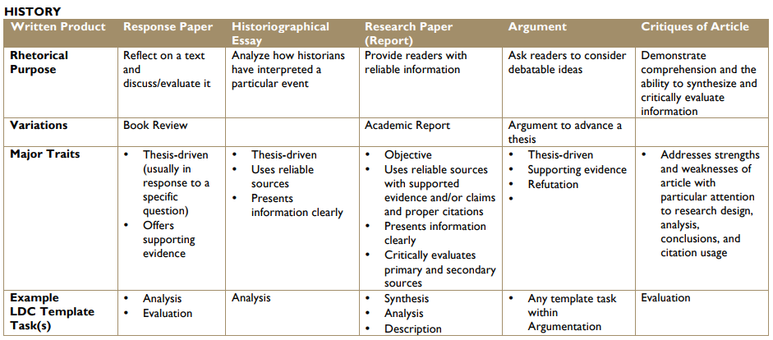
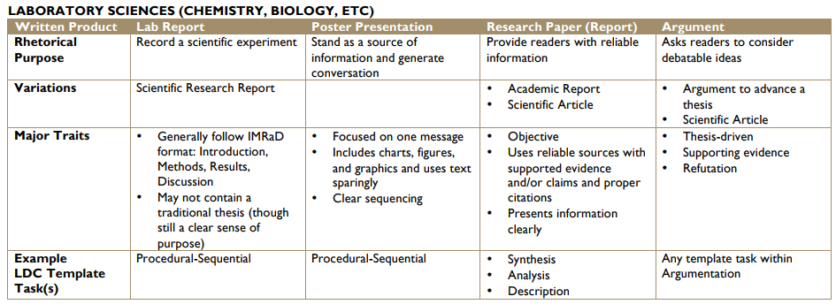
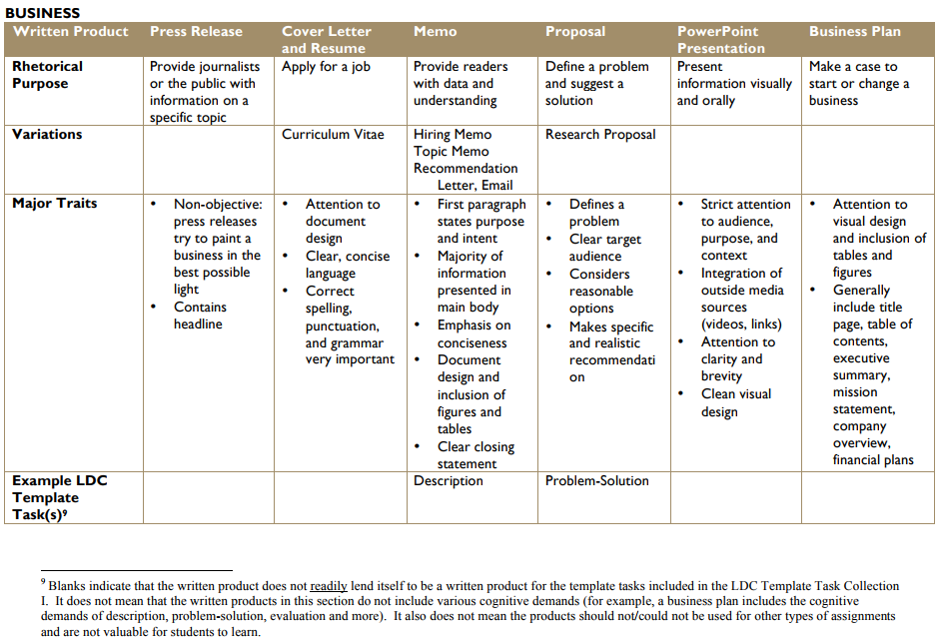
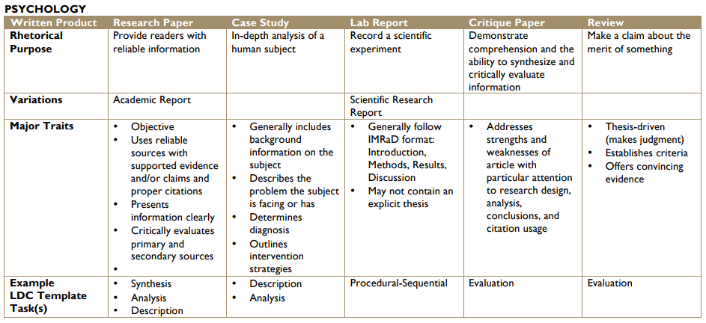
EXHIBIT K:
WORKSHEET: Interdisciplinary Research Questions
Key steps to creating an interdisciplinary research question
- Use all disciplinary tools, including assumptions, concepts, theories, and methods, to solve the problem
- Critically evaluate disciplinary insights
- Create common ground among disciplinary insights… on the basis of one or more key assumptions, concepts, or theoretical explanations

Example Course: “Positive Psychology and the Pursuit of Happiness in Chicago”
Initial Research Question: “What is your favorite place in the city, and which theoretical concepts from class would you use to explain what makes it your favorite place?”
- Key concepts from Positive Psychology:
- Social contact (“Attachment”)
- Sensory stimulation
- Relaxation
Key concepts from City Planning:
- Traffic flow
- Green zones
- Vibrant shopping & entertainment centers
2. Disciplinary insight from Positive Psychology:
- People tend to be happiest in low-traffic environments
Disciplinary insight from City Planning:
- Heavy car traffic in downtown areas is bad for shopping and recreation activities
- Common ground among disciplinary insights:
- Green zones support Relaxation
- Shopping and entertainment centers provide sensory stimulation
- (Massive) traffic flow disrupts social contact
Subsequent Research Question: “How to avoid or minimize disruptive traffic flow in downtown?”
=====================================================================================List of Big Questions across Disciplines:
- Where should society benefit most from science?
- Can economic growth go on forever on a finite planet?
- To what degree is personality innate or learned?
- What do we know when we know a person?
- Does humanity have a future beyond earth?
- Will brain science change criminal law?
- Will sex become obsolete?
- Will technology eliminate the need for animal testing in drug development?
- What role will science play in the future of cities?
- What makes us human?
- Can we live forever?
- Why have humans evolved music?

