How can you influence your students’ anxiety?
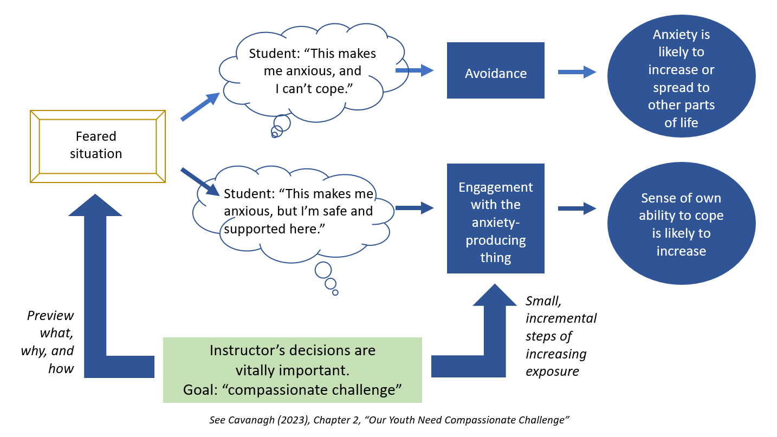
Feared situations might relate to tasks or to topics. For instance, a student might fear having to give a 3-minute presentation in class. Another student might fear having to see images of World War II atrocities.

Cultivate trust by helping students feel relatively safe in encountering the feared task or topic. Here are two approaches:
- Preview or frame the feared task/topic for students in advance. For example:
  - Adding a syllabus statement to alert students to a topic that might be particularly difficult to engage with. Note why this is an important topic.
  - Making a verbal announcement at the beginning of the semester and addressing why a certain topic has been included and how it relates to the learning objectives for the course.
  - Reminding students prior to teaching
  - Discussing alternative assignments with students
  - Discussing your approach to teaching that specific topic and how you would expect students to engage with the material
- Guide students to engage with the feared task/topic in incremental steps of increasing exposure. For example:
  - Exposure to a relatively mild, still image
  - Exposure to a text
  - Exposure to an audio recording
  - Exposure to a video
  - Student reflection on their experience engaging with the material

Applying these ideas to your own teaching context

- Thinking about a class you teach, what is a task or topic that seems to increase students’ anxiety?

- Are there ways you do/can help students feel relatively safe in encountering the feared task or topic? List a few ideas about how you might:
  - Preview or frame the feared task/topic for students in advance:
  - Guide students to engage with the feared task/topic in incremental steps of increasing exposure:
A good source for further ideas: Cavanagh, S. R. (2023). Mind over monsters: Supporting youth mental health with compassionate challenge. Beacon Press

