Instructors have a crucial impact on classroom climates
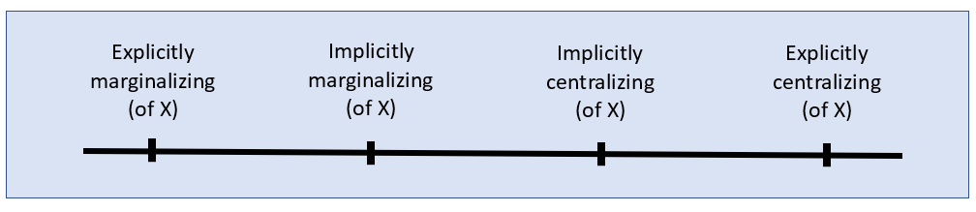
Based on DeSurra & Church (1994), as discussed in Ambrose, S. A., et al. (2010). How learning works: Seven research-based principles for smart teaching, pp. 171-173. Jossey-Bass.
Examples—Assuming that Topic X is both 1) relevant to the course material and 2) a contested or sensitive issue:
- Explicitly marginalizing: A student says, “People from ___________ (some group) believe ____________ (something about Topic X), and they’re completely wrong.” The instructor responds, “We’re not talking about Topic X in this class.”
- Implicitly marginalizing: The instructor never mentions Topic X, even though it is relevant to the course material.
- Implicitly centralizing: The instructor mentions Topic X after a student mentions it first. (A student has to take the risk of introducing the controversial topic.)
- Explicitly centralizing: The instructor designs the course so that Topic X is discussed.
Example scenario from Chas:
When I was an undergrad, I took a social psychology class with about 120 students. The instructor, a graduate student, was quite good. One day, in a discussion of some topic that I don’t recall, the instructor said, “And because some people in this room probably are homosexual, I should mention ________ (some concept).” [The instructor was explicitly centralizing LGBT people]
At that moment, some students in the room uttered a loud groan of disgust. [Explicitly marginalizing LGBT people]
I don’t remember how the instructor responded or whether she did anything at all. (I’m gay, and hearing the groan of disgust made me lose my concentration on the course material.) If the instructor did nothing at that point, that would be implicitly marginalizing. If she said something like “Oh, come on – some people are gay and their lives deserve to be explored,” that would be explicitly centralizing.

